
MATHEMATICS APPLICATIONS
Test 6 2018
Piecewise and Simultaneous Linear Functions
Resource Free
Marks: 22 Time Allowed: 25 minutes

TOTAL: 47 Name: _______________
ALL working must be shown for full marks.
For full marks you will need to show all your working out.

Question 1 [2, 3, 3 = 8 marks]
- Solve the following Linear functions

i) 4y - 6 = 30 ii) 3(x + 8) - 2 = 7

- Give the equation that represents the following situation and then solve to find the value of x.

“Three times a number is divided by four and then two is added. The result is one less than the original number”

Question 2 [3, 3 = 6 marks]

Solve the following simultaneous equations using the method stated below.

- 2x + 3y = 6 and 5x – 3y = -27 by Elimination method.

- x - 3y = 7 and y = x – 1 by Substitution method.

Question 3 [3 marks]
Graph the following function on the axis below.

y = -x -3 x ≤ -5
y = 1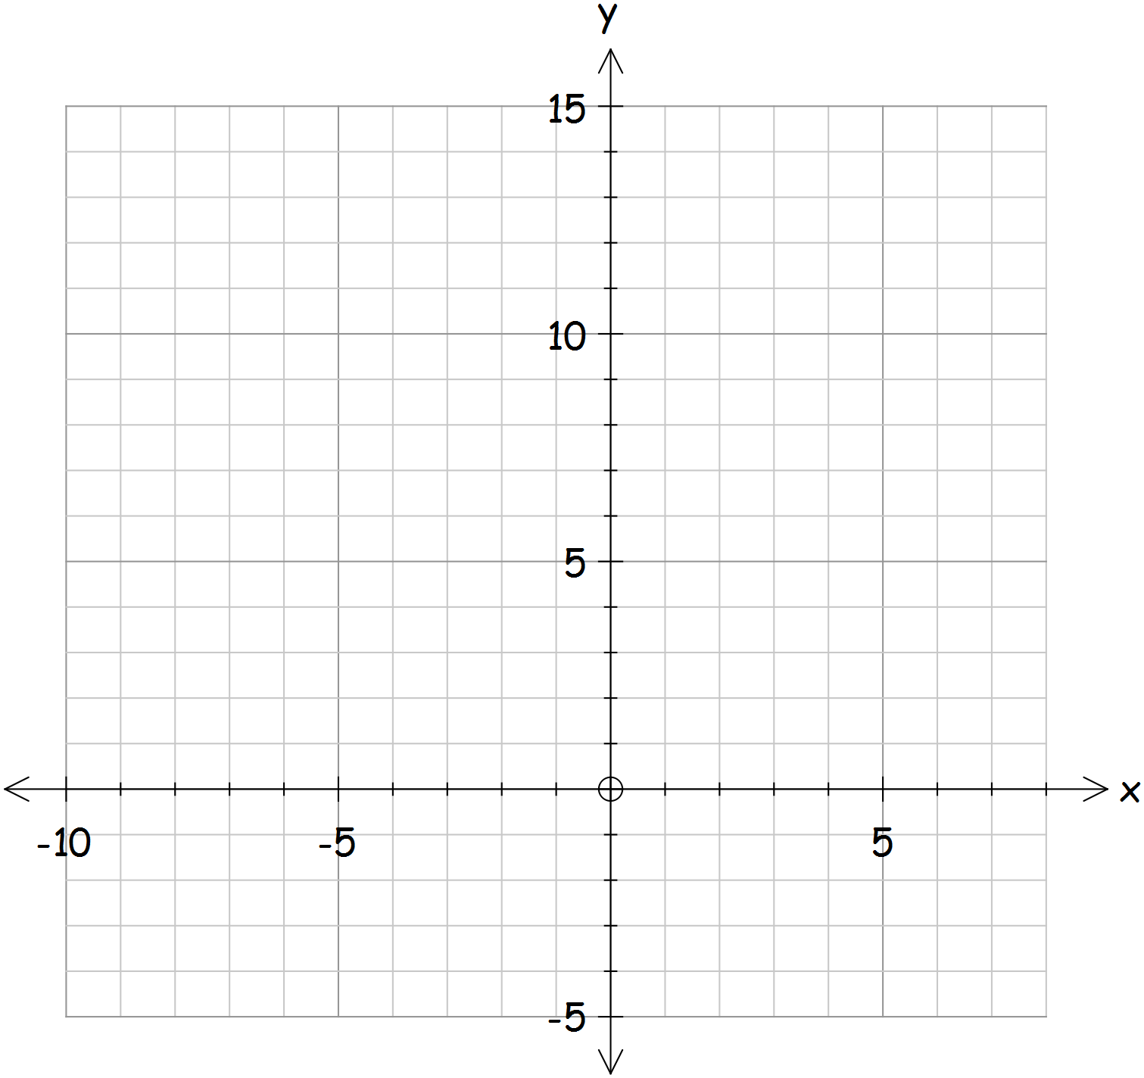 -5 ‹ x ‹ 1
y = 3x 1 ≤ x

Question 4 [4, 1 = 5 marks]
- Sketch the graph for the following equations y = 6 - 2x and 5y = 10x + 10.
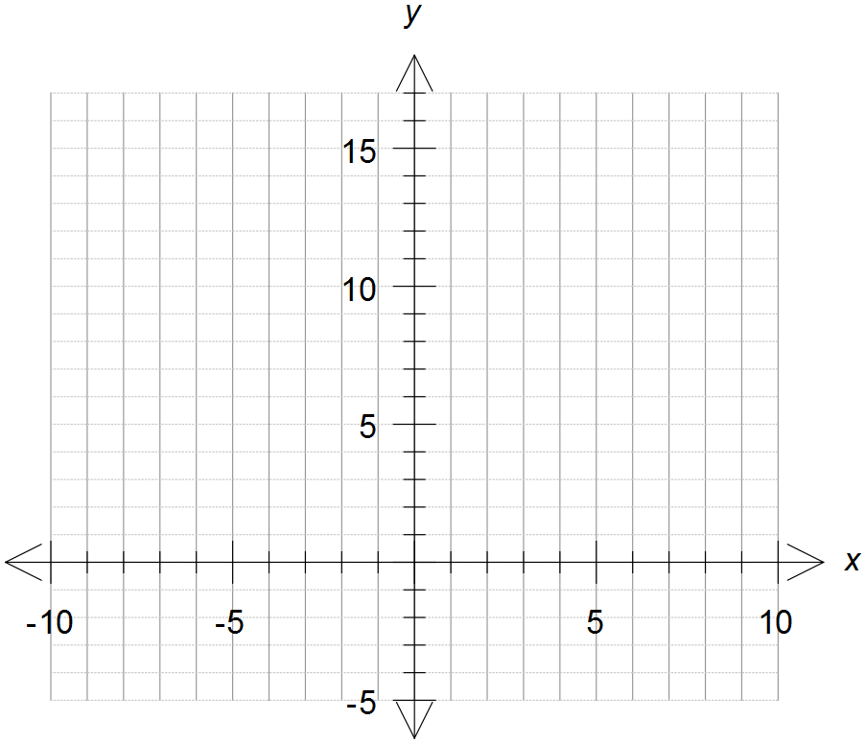

- Find the point of intersection for the two equations from the graph.


MATHEMATICS APPLICATIONS
Test 6 2018
Linear Functions
Section B-Resource Assumed
Marks: 25 Time Allowed: 25 minutes

ALL working must be shown for full marks.

Question 1 [2, 2 = 4 marks]
Find the point of intersection between the following equations

- y = 2x + 10 and y = 3.5x + 0.5

- 5(2x – y) + 4y = 3(3x + 1) and 5(2x – 1) =5x – 2y + 38

Question 2 [2, 2 = 4 marks]
To promote the school Fete two poster companies have considered.
Polly’s posters charge $175 to design the poster and $3 for each poster she makes.
Pete’s posters charge $250 to design the poster and $2 for each poster he makes.

- Write down an equation to find the cost of producing (n) posters for each company.
Use C for the cost and n for the number of posters.

- What company should the school use if they need 40 posters. Why?

Question 3 [2, 1, 1, 1, 2 = 7 marks]
The piecewise graph below shows the annual premium (cost) of life insurance for men of different ages.
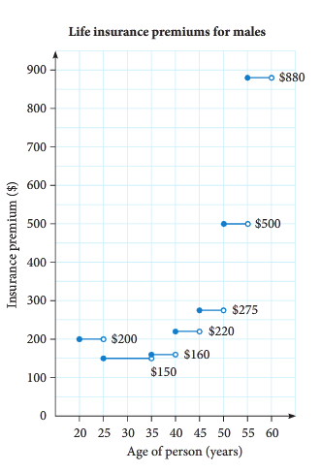
- What is the annual premium for a man aged:
- 24 years?

- 52 years?

- Why is the cost different?

- For what age group is the cost $275

- What is the age of the youngest man who
can pay a premium of $160.

- For what age ranges does the price reduce
as you get older? Why?

Question 4 [2, 2, 1, 2, 1, 2 = 10 marks]
Amber is a plumber. She charges $60 for arriving at a job, and $75 per hour that she works.
- Use the information above to complete this table
Time worked, t (hours) | 0 | 1 | 2 | 3 | 10
Cost,C($)

- Graph the data in the table on the axis below.

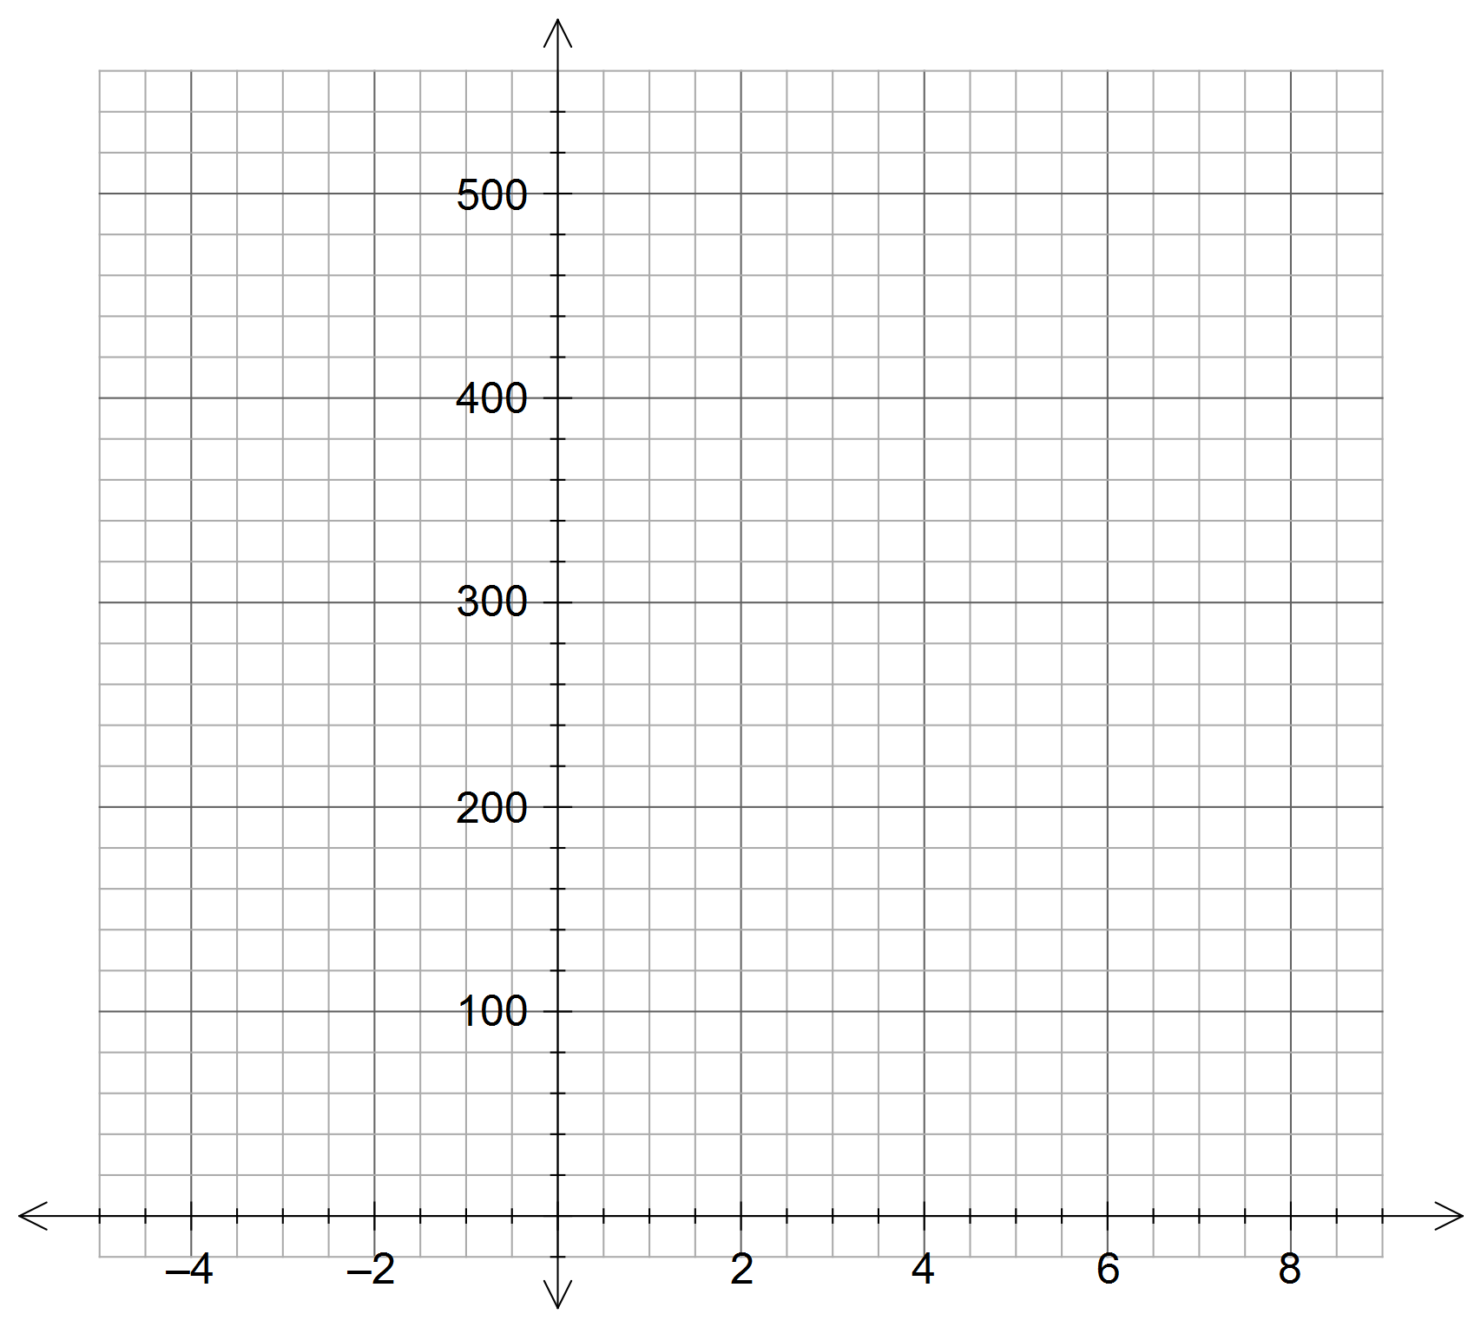

- What is the significance of the intercept on the y axis?

- Determine the equation of the line for the relationship between t and C.
(must be in terms of t and c)

- What is the significance of the Gradient?

- Use your graph to answer the following questions
i) How much would Amber charge for working 6 hours?

ii) How long has Amber worked if she charges $360?

